**Module Name: Fundamentals of OOP**

**Module Code: 5N0541**

**Assignment Name: Skills Demonstration I**

**Weighting: 20%**

**Your Name: Steven Joyce**

**Class Group: Computer Science**

**Tutor Name: Darren Stones**

**Issue Date: 21st October 2016**

**Due Date: 17th November 2016**

**Combined Template for: FOOP Skills Demo One & Programming Design Principles Skills Demo One**

**SECTION ONE: CLEARLY DOCUMENTED SOURCE CODE**

1. Simple algorithm provided to solve problem statement:

1.Initialize all variables required for your program. Int, Long, boolean

2.Create a Do-While loop and in Do-part put the next steps.

3. Create scanners: user_input, input1, operatorInput, userInput

3. Create a Switch Statement with Case(user_input) called-M, B & R.

4.In each Case put; System.out.print("Please enter your first number/value: " ); System.out.print("Please enter your operator(+,-, * or /): " ); System.out.print("Please enter your second number/value: " );

AND an IF Statement to answer question WITH the proper operator.

5.Close of the IF and the Switch statements and put a new line called System.out.println("Do you wish to do another calculation? (Y/N): " );

ans = userInput.nextLine(); //

6. End the do loop and with the While put: ("Y".equals(ans));

1. Record of comments to be used in program (please provide four examples) :

//declare input variables  
//creating an object of the scanner class //If statement to use the userinput to solve problem

//do while loop to ask user if they want to do a new calculation or not?

**SECTION TWO: PROGRAM FUNCTIONALITY**

1. Please provide an appropriately cropped and resized screenshot of your **final** program working and insert in the section below:

*Input and output screenshot displaying prudent use of print formatting*

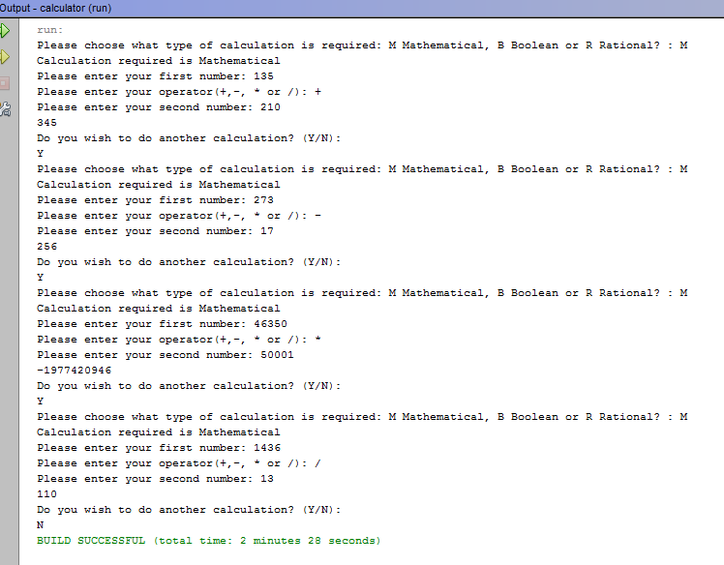

**SECTION THREE: ACCURATE PROGRAMMING (SYNTAX & SEMANTICS)**

1. Identify all the named identifiers (class, method, fields/variables) in your program in the table below:

|  |  |  |
| --- | --- | --- |
| **Variable Name(s)** | **Purpose** | **Data Type** |
| IF-else | To perform a condition test | long |
| Do-while | To repeat the program, if userInput types Y | String |

1. Identify the appropriate data type conversion performed in your program below:

|  |  |  |
| --- | --- | --- |
| **Name of variable** | **Original data type** | **Data type conversion/cast** |
| firstValue | Int | Long |
| secondValue | Int | Long |
| operator | int | Long |

1. Printout of the final program with comments and line numbers:

**SECTION FOUR: EVIDENCE OF SOFTWARE TESTING/ DEBUGGING**

1. Provide a screenshot of at least one bug or problem found in your code:

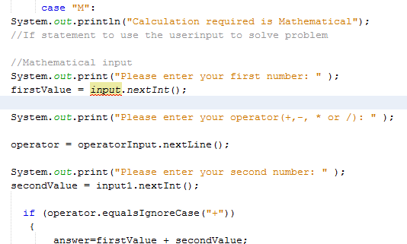

1. Briefly explain how you overcame this error:

I overcame this problem by looking through my code and finding the right scanner object to put in that line of code.

1. Provide a screenshot of your final programming running using the following input and indicate the output you expect to see before the program is compiled:

|  |  |  |  |
| --- | --- | --- | --- |
| **Input Data** | **Operation** | **Expected Output prior to running program** | **Record actual output from running program here** |
| **135, 210** | **+** | **435** |  |
| **273, 17** | **-** | **356** |  |
| **46350, 50001** | **\*** | **2317546350** |  |
| **1436, 13** | **/** | **110.4615384615385** |  |

1. Please provide relevant screenshot(s) using the input data from the table above:

